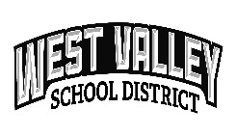 | WEST VALLEY SCHOOL DISTRICT NO.208  MEDIA RELEASE (rev. May. 2022)

Web Site Use of Photo or Other Illustrating Materials
Student safety and security regarding the development of the West Valley School District web site has always been a high priority. Our schools often use individual student(s) and or class photos in their school websites. These are used to help bring a sense of connection to our community and help highlight what our students have achieved during the school year(s).
- No, I do not give permission for my child’s photo or other illustrating materials to be on the District Web Site for West Valley School District.

Student Name______________________________________________________

Legal Parent/Guardian Signature ________________________________________ Date_____________

Publication of Photo
West Valley School District often uses photographs, videos and or other illustrating materials of students. Uses include but not limited too; educational slide presentations, websites about our schools within the district, news coverage for school-related news, year book and district/individual school newsletters.

This form gives you as the parent/guardian to choose if your child can be in school related photographs, videos and or other illustrating materials.

- No, I do not give permission for my child(ren) to be a part of a presentation or
documentation done by West Valley School District or news media.

Legal Parent/Guardian Signature ________________________________________ Date_____________

